**Distributed Systems**

**Lab-7**

Naga Tharun Makkena

SE20UCSE105

Problem 1: Write a Program to implement locking algorithm.

Code:

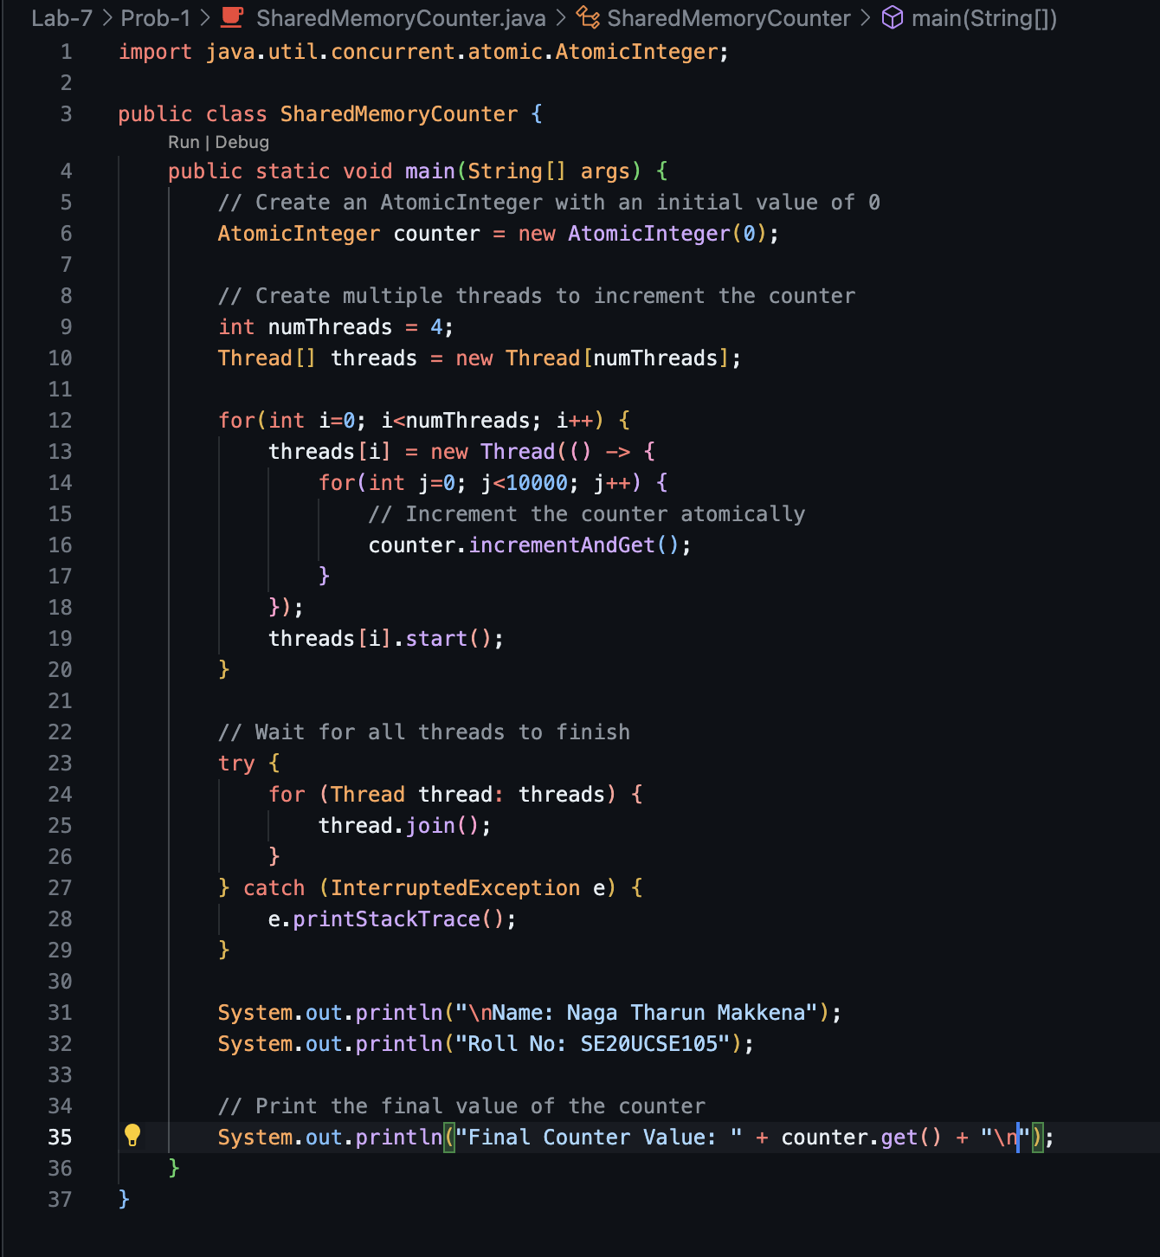

Output:

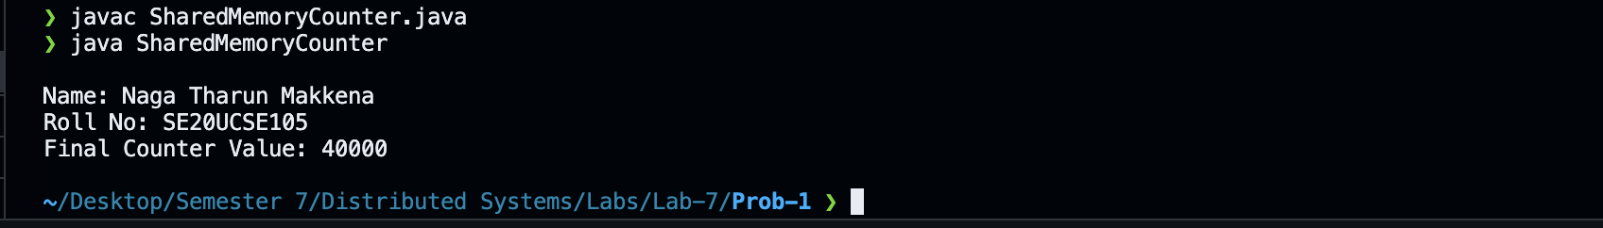

Problem 2: Create CORBA based server-client application.

[Tools/ Apparatus: CORBA Runtime: inbuilt in Java Standard Edition Runtime JDK]

Code:

